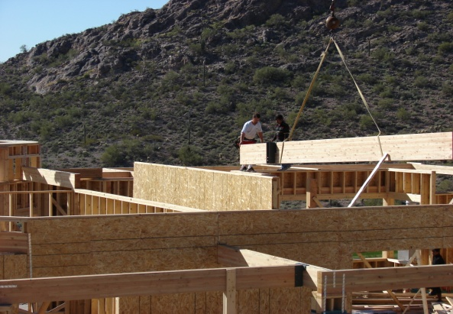

**Construction Features**

2 x 6 (minimum) Exterior Framed Walls

Interior Walls Framed 16” on center

Fully Sheated Exterior Plywood

Recessed Window Detail

Upgraded Roof Underlayment

Synthetic Stucco System

3000 psi concrete

Natural Gas Homes (where available)

**Exterior Features**

Multiple Height Elevations

Andersen Windows

Classic Exterior Doors

Color-thru Concrete Roof Tile

Roof Venting to Rear

Large Covered Patios with High Arches

Significant Allowance for Front Entry Door*

Synthetic Stucco and Color Coat System

**Insulation Package**

1” Foam Panel over ½” Plywood

Exterior Walls - Closed Cell Foam Insulation x 6”

Roof – Open Cell Foam Insulation to Roof Deck x 6”

Garage Overhead Doors w/Insulated Foam Panels

Dual Glazed Window Glass

**Electrical Systems**

200A min. Electrical Service w/100A Sub-Panel

Recessed Lighting Fixtures

Cabinet Lighting in Kitchen (Above and Below)

Ceiling Fans Wired Thru-out

Prep for Outdoor Lighting System

Prep for Irrigation

Prep for Pool/Spa

Jacuzzi Circuit

Liftmaster Belt Drive Garage Door Openers

**Plumbing Systems**

75 Gallon Hot Water Heater

Soft Water Loop

Reverse Osmosis Line To Refrigerator and Sink

Kohler 8” Wide-Spread Vanity Faucets

Moen Shower Valves

Toto Hi-Seat Toilets w/Self Closing Lids

Laundry Sink

**HVAC Systems**

Bryant or Carrier 13.5+ SEER Air Conditioning Units

Programmable Electronic Thermostats

Conveniently Accessed Unit Installation

**Low Voltage Systems**

ADEMCO Whole-House Security System

Central Vacuum Pre-piped

Surround Sound System Pre-wire

Structured Wiring Interface Panel

(8) RG6 Cable or Satellite Outlets

(8) Cat5 Phone/Network Outlets

**Gourmet Kitchen Features**

Custom Select Alder Wood Cabinets w/42” Uppers

Custom Refrigerator and Dishwasher Doors

3cm Level III Granite Countertops

Under-mount Granite Composite Sink

Pull-out Trash Container

Significant Appliance Allowance*

Walk-in Pantry

**Interior Doors**

8’ Solid Wood Canyon Custom Doors

4 Coat Wood Finish

Emtek Door Hardware

**Flooring**

Travertine Flooring Thru-out Main Living Area

Plush Berber Carpet in Bedrooms and Closets*

**Accessories**

Significant Allowance for Bathroom Accessories*

Framed Mirrors*

**Interior Features**

9’ to 14’ Ceiling Heights

Santa Fe Drywall Finish

2-Tone Dunn Edwards Paint

Coffered Ceilings in Kitchen, Great Room and Master Bedroom

Spacious Walk-In Showers w/Travertine Tile

Handi-cap Accommodations

Closet Systems – All Bedrooms

Custom Wood Medicine Cabinets

Custom Laundry Room Cabinets

42” Gas Fireplaces w/Natural Gas Logs

Lighted Niches and Pot-shelves

Custom Entertainment Niches

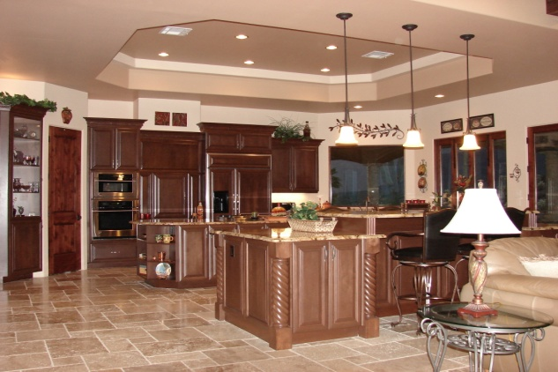

**See Reverse Side for FLOORPLAN**

